LIBRARY MANAGEMENT SYSTEM
@CREATIVITY THINK (9483175986/7019689991)

ABSTRACT:
The Library Management System is a web-based application designed to efficiently manage book inventories, track issuance and returns, handle fines, and provide analytics for library operations. Users can search for books, request issuance, return or renew items, track borrowing history, and receive reminders and fine notifications. Administrators can manage book inventories, oversee members, handle overdue fines, send notifications, and analyze library usage through dashboards. Built with Django and Django REST Framework for backend processing, and React with Axios and Data-grid for frontend interaction, the system offers a reliable, scalable, and efficient solution for modern library management..

INTRODUCTION OF THE PROJECT:
Library management often involves manual tracking or disparate software, leading to difficulties in managing books, users, fines, and reporting. The Library Management System addresses these challenges by providing a centralized, digital platform for book issuance, return, fine management, and analytics. Users benefit from seamless access to book inventories, issue/return tracking, and reminders. Administrators can efficiently manage books, members, fines, and monitor library performance using real-time dashboards, improving operational efficiency and accountability..

PROJECT OBJECTIVES:

• Provide a centralized platform for library book management
• Enable users to search, request issue/return, and renew books
• Track borrowing history and display notifications for due dates and fines
• Allow administrators to manage book inventory, members, and fines
• Provide dashboards for library usage analytics
• Send notifications and messages to members regarding updates or overdue books
• Support secure role-based access and scalable backend services
• Reduce manual errors and improve operational efficiency

PROBLEM OF THE STATEMENT:
Traditional library management methods are often manual, error-prone, and time-consuming. Users face difficulty tracking borrowed books, due dates, and fines, while administrators lack visibility into book circulation and member activities. The Library Management System solves these issues by offering a digital, interactive, and analytics-enabled solution that automates book tracking, fine handling, notifications, and provides actionable insights for administrators..

MOTIVATION OF THE PROJECT:
• To digitalize library operations and improve accessibility
• To allow users to track borrowing history and manage book returns effectively
• To automate reminders and fines handling for accountability
• To provide administrators with efficient management tools and analytics
• To reduce manual workload and minimize errors
• To support scalable operations for schools, public, or private libraries
• To offer a user-friendly interface for both members and administrators

BLOCK DAIGRAM OF PROJECT:

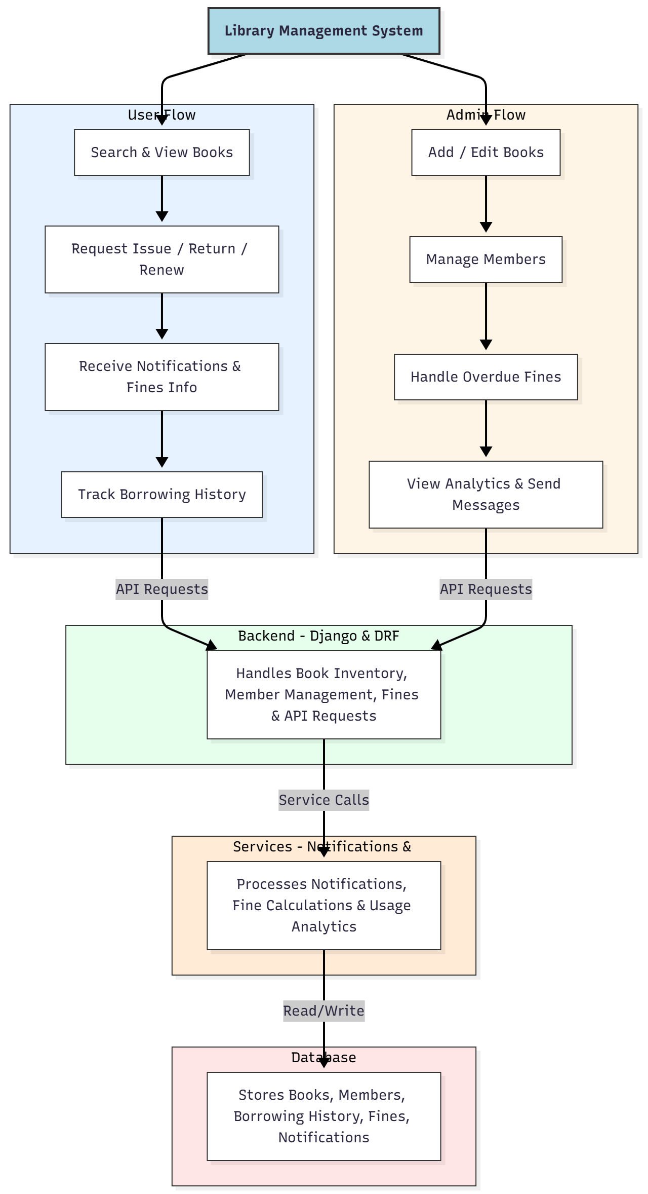

WORKING OF THE PROJECT:
Users can search and view available books, request book issuance, renewals, or returns. Notifications alert users about due dates, fines, or other important updates. Users can track their borrowing history and pending fines through a dashboard. Administrators manage the book inventory, handle member registrations, process overdue fines, and send messages to users. All data interactions are processed through Django REST APIs, with notifications and analytics handled by the services module and stored securely in the database. This ensures streamlined, accurate, and accountable library management..

SOFTWARE REQUIREMENT:
- Backend:
  - Python 3.x
  - Django
  - Django REST Framework
  - SQLite/PostgreSQL
- Frontend:
  - Node.js and npm
  - React.js
  - Axios
- Development Tools:
  - Visual Studio Code
  - Postman (for testing APIs)
  - Git/GitHub (for version control)
- Server/Deployment (Optional):
  - Gunicorn, Nginx, or Heroku/AWS for hosting

ADVANTAGES OF THE PROJECT:

• Centralized management of library books and members
• Automated notifications and fine handling
• Accurate tracking of borrowing and return history
• Analytics dashboard for administrators
• Reduces manual errors and administrative workload
• Enhances user experience and accountability
• Scalable for small and large libraries
• Secure and reliable web-based platform

APPLICATIONS OF THE PROJECT:
• School libraries
• Public libraries
• Private libraries
• College and university libraries
• Community centers
• Corporate libraries

REFERENCES:

- Django REST Framework Documentation — Django Software Foundation. Django Documentation. Available: https://docs.djangoproject.com/
- Django REST Framework. DRF Documentation. Available: https://www.django-rest-framework.org/
- React. React Official Documentation. Available: https://reactjs.org/docs/getting-started.html
- Redux. Redux Documentation. Available: https://redux.js.org/introduction/getting-started
- PostgreSQL Global Development Group. PostgreSQL Documentation. Available: https://www.postgresql.org/docs/
- MySQL. MySQL Reference Manual. Available: https://dev.mysql.com/doc/
- Git. Git Documentation. Available: https://git-scm.com/doc
- Node.js. Node.js Documentation. Available: https://nodejs.org/en/docs/
- Axios. Axios Documentation. Available: https://axios-http.com/docs/intro
- Socket.io Documentation – https://socket.io/docs/

